Chapter 13, Solution 51.

Use the concept of reflected impedance to find the input impedance and current I₁ in Fig. 13.116 below.

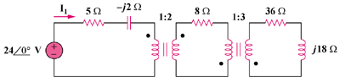

Figure 13.116
For Prob. 13.51.

Solution

Let Z₃ = 36 +j18, where Z₃ is reflected to the middle circuit.

Z_{R}’ = Z_{L}/n² = (12 + j2)/4 = 3 + j0.5

Z_{in} = 5 – j2 + Z_{R}’ = [8 – j1.5] Ω

I₁ = 24∠0°/Z_{eq} = 24∠0°/(8 – j1.5) = 24∠0°/8.14∠–10.62° = 8.95∠10.62° A

[8 – j1.5] Ω, 8.95∠10.62° A

